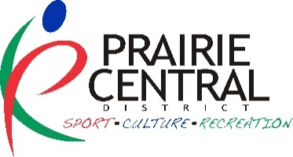
PRAIRIE CENTRAL DISTRICT
SPONSORSHIP APPLICATION FORM

2026-2027 PRIDE PROGRAM + INITATIVE MICROGRANT

NAME OF COMMUNITY ORGANIZATION:

Contact Person: Phone:

Address (box #, town & postal code):

Email:

Alternate Contact: Phone:

Email:

____________________________________________________________________________________________

Name of the initiative?

Who is the target audience?
What is the initiative?

When will it happen?

How will you promote this initiative?

Where will it be held?

Why are you doing this initiative? What changes are you planning/hoping for?

How will you evaluate this initiative?

Where did you hear about this grant? Website E-News Social Media Other:

PROPOSED BUDGET: (list expenses and revenues specific to the initiative – Max PCD allocation is $500)
Expenses: | Amount | Revenues: | Amount
 | $ | Request from Prairie Central District | $
 | $ |  | $
 | $ |  | $
 | $ |  | $
 | $ |  | $
Total Expenses: | ____________ | is equal to Total Revenues: | _____________

Budget notes:

PRINT CONTACT NAME SIGNATURE CONTACT

PRINT CAO or RECREATION AUTHORITY & TITLE (not same as contact) SIGNATURE CAO or REC AUTHORITY

Send completed applications to: Prairie Central Community Consultants: aileen@prairiecentral.ca
