COMMUNITY ENGAGEMENT & DEVELOPMENT PROGRAM
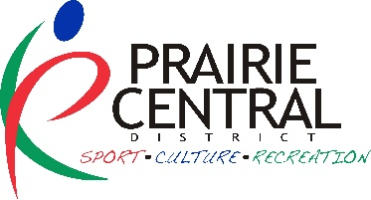
FRAMEWORK IN ACTION GRANT
APPLICATION FORM

NAME OF COMMUNITY ORGANIZATION:

Contact Person: Phone:

Address (box #, community & postal code):

Email:

Alternate Contact: Phone:

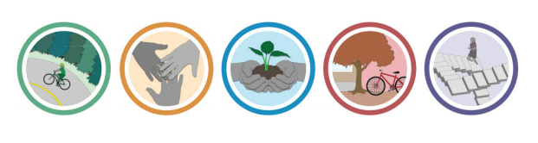
Email:
FRAMEWORK GOALS:

Identify which goal(s) your initiative best aligns with:

_____ 1. ACTIVE LIVING
- Foster active living through physical recreation

_____ 2. INCLUSION AND ACCESS
- Increase inclusion and access to recreation for populations that face constraints to participation.

_____ 3. CONNECTING PEOPLE AND NATURE
- Help people connect to nature through recreation.

_____ 4. SUPPORTIVE ENVIRONMENTS
- Ensure the provision of supportive physical and social environments that encourage participation in recreation and build strong, caring communities.
_____ 5. RECREATION CAPACITY
- Ensure the continued growth and sustainability of the recreation field.

Name of the initiative?

Who is the target audience? (ie: Children, Youth, Adults, Adults 55+, Indigenous People)
What is the initiative?

When will it happen?

Where will it be held?

Why are you doing this initiative? What changes are you planning/hoping for?

How will you promote this initiative?

How will you evaluate this initiative?

Where did you hear about this grant? Website E-News Social Media Other:

PROPOSED BUDGET: (list expenses and revenues specific to the initiative)
Budget notes:
Expenses: | Amount | Revenues: | Amount
 | $ | Request from Prairie Central District | $
 | $ |  | $
 | $ |  | $
 | $ |  | $
 | $ |  | $
Total Expenses: | ____________ | is equal to Total Revenues: | _____________

CONTACT SIGNATURE NAME OF COMMUNITY

PRINT RECREATION AUTHORITY & TITLE (not same as contact) RECREATION AUTHORITY SIGNATURE
Send completed applications to:
Prairie Central District for Sport, Culture and Recreation
Box 818 Wynyard, SK S0A 4T0
Or email to Prairie Central Community Consultants: aileen@prairiecentral.ca or kathryn@prairiecentral.ca
