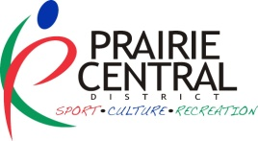COMMUNITY ENGAGEMENT & DEVELOPMENT PROGRAM
FRAMEWORK IN ACTION GRANT
FOLLOW UP FORM

NAME OF THE INITIATIVE:

DATE(S): LOCATION:

Contact Person: Phone:

Email:

Grant Payable: E-transfer to: __________________________________________________ OR

Cheque to (name of organization): ____________________________________________________
Mailing Address (box #, community, postal code):

LET’S HEAR THE DETAILS:

What target group was the initiative for?

Indicate which groups participated and approximately how many participants:

- Children
- Youth
- Adults
- Adults (55+)
- Indigenous People

Communities within the District that were represented:

How many volunteers did you have?

How did you recruit volunteers?

How did you thank the volunteers?

Framework Goals:
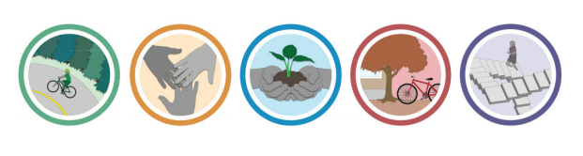
Which goal(s) did your initiative align with?

_____ 1. ACTIVE LIVING
- Foster active living through physical recreation
_____ 2. INCLUSION AND ACCESS
- Increase inclusion and access to recreation for populations that face constraints to participation
_____ 3. CONNECTING PEOPLE AND NATURE
- Help people connect to nature through recreation

_____ 4. SUPPORTIVE ENVIRONMENTS
- Ensure the provision of supportive physical and social environments that encourage participation in recreation and build strong, caring communities
_____ 5. RECREATION CAPACITY
- Ensure the continued growth and sustainability of the recreation field

On your application you indicated desired outcomes, which of these were met? Which were not? Why?

What was the greatest success of this project?

What was the biggest challenge/barrier with this project? Did receiving the CEDP – FIA grant assist to minimize or eliminate this barrier? Yes No How?

BUDGET

Expense | Amount | Revenue | Amount
 | $ | Prairie Central District | $
 | $ |  | $
 | $ |  | $
 | $ |  | $
 | $ |  | $
 | $ |  | $
 | $ |  | $
Total Expenses: | $ | Is equal to Total Revenues: | $
Attach to this follow-up report:
- Copies of actual receipts for approved expenses.
- Copies of promotional items (ie: brochures, newspaper ads or write-ups, posters, programs, etc.).
- Photos & participant comments (consent of use received by the organization)

Completed follow-up report with all of the above supporting materials must be received within 30 days of project completion to the address below.

I,__________________________________________ certify this to be an accurate account of the above project.
^{Contact signature}

Prairie Central District for Sport Culture and Recreation
Box 818 Wynyard, SK S0A 4T0
Or email to Prairie Central Community Consultants:
aileen@prairiecentral.ca
kathryn@prairiecentral.ca

