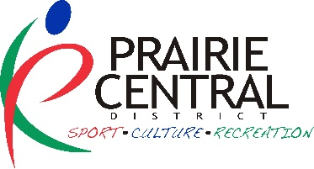
PRAIRIE CENTRAL DISTRICT
MICRO GRANT: EVENT SPONSORSHIP APPLICATION FORM

PRIDE MONTH EVENTS + INITATIVES 2025

NAME OF COMMUNITY ORGANIZATION:

Contact Person: Phone:

Address (box #, town & postal code):

Email:

Alternate Contact: Phone:

Email:

____________________________________________________________________________________________

Name of the initiative?

Who is the target audience?

What is the initiative?

When will it happen?

How will you promote this initiative?

Where will it be held?

Why are you doing this initiative? What changes are you planning/hoping for?

How will you promote this initiative?

How will you evaluate this initiative?

Where did you hear about this grant? Website E-News Social Media Other:

PROPOSED BUDGET: (list expenses and revenues specific to the initiative – Max PCD allocation is $500)
Expenses: | Amount | Revenues: | Amount
 | $ | Request from Prairie Central District | $
 | $ |  | $
 | $ |  | $
 | $ |  | $
 | $ |  | $
Total Expenses: | ____________ | is equal to Total Revenues: | _____________

Budget notes:
CONTACT SIGNATURE NAME OF COMMUNITY

PRINT RECREATION AUTHORITY & TITLE (not same as contact) RECREATION AUTHORITY SIGNATURE

Send completed applications to: Prairie Central Community Consultants: aileen@prairiecentral.ca

